MSSQL(Microsoft SQL Server)
https://drive.google.com/drive/u/0/folders/1CD1kSn7cZ9ReiVL1RTHMv_yQ47Y49oAk
What does sp_help do in SQL Server?
sp_help provides detailed information about a database object — typically a table or view. It returns metadata such as column definitions, data types, identity columns, indexes, constraints, and relationships like foreign keys. It's useful for quickly analyzing a table's structure
Syntax : sp_help sales_1 (here sales_1 is a table name)

- DBO(Database Owner)
It’s the default schema that SQL Server assigns to objects created by users when no schema is explicitly specified.
CREATE TABLE dbo.tblstudent (...)
This creates the table in the dbo schema.

It is functionally equivalent to:
CREATE TABLE tblstudent (...)
If the current user's default schema is db.

1.Difference between DDL & DML
DDL Deals with the structure of the database and its objects. It is used to create, modify, or delete database objects like tables, schemas, indexes. Changes the structure, not just the data.

CREATE, ALTER, DROP, TRUNCATE
DML Deals with the data inside the tables. Used to insert, update, delete, or retrieve data. Only the data, not the structure of tables.
SELECT, INSERT, UPDATE, DELETE
2. Is Alter/Update DDL or DML & why?
ALTER is used to change the structure of database objects. It is used to
- Add or drop a column
- Modify a column’s data type
- Rename a table or column
- Add or remove constraints
You're not changing data; you're changing the definition of the table itself — that's why it's DDL
- ALTER TABLE tblstudent
ADD GENDER VARCHAR(20) NULL ,mobile_no INT NULL ;

UPDATE is used to modify the data inside a table.
The structure of the table stays the same — only the values in specific columns are changed.
Since you're working with the contents, not the design, it's classified as DML.

- rename table in mssql
In SQL Server (MSSQL), to rename a table, you use the sp_rename
EXEC sp_rename 'old_table_name', 'new_table_name';
- Alter the datatype of a column
This changes the data type of Tempaddress to NVARCHAR(1500).

ALTER TABLE tblstudent
ALTER COLUMN Tempaddress NVARCHAR(1500);
- Drop the column
ALTER TABLE tblstudent
DROP COLUMN Tempaddress;
- Rename column name
If you have a table Employees and want to rename the column fullname to name, you'd do:
EXEC sp_rename 'Employees.fullname', 'name', 'COLUMN';
--UPDATE
UPDATE tblstudent SET address='SARJAPURA MAIN ROAD' WHERE student_code='S004'

--UPDATE FROM ANOTHER TABLE
UPDATE tblstudent SET address= (select city from orders_1 where order_id=113) WHERE student_code='S004'

---UPDATE WITH TOP
UPDATE TOP(3) tblstudent SET address= (select city from orders_1 where order_id=113)

- In MySQL, renaming a table is simple and straightforward.
RENAME TABLE old_table_name TO new_table_name;
Q. Merge query
The MERGE statement in MSSQL is used to combine INSERT, UPDATE, and DELETE operations into a single SQL statement — based on whether matching rows exist in a target table
Merge Employee_Target AS T
Using Employee_Source AS S
ON T.id=S.id
WHEN MATCHED THEN
UPDATE SET T.name=S.name
WHEN NOT MATCHED BY TARGET THEN
INSERT (id,name) values (S.id,S.name)
WHEN NOT MATCHED BY SOURCE THEN
DELETE;

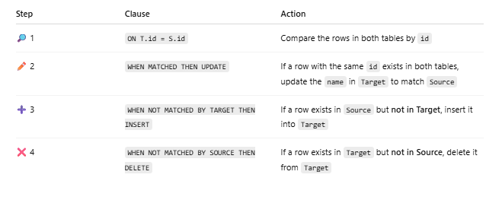

3.Difference between delete & drop query
Q. Difference between char & varchar
Q. Explain the type of SQL commands
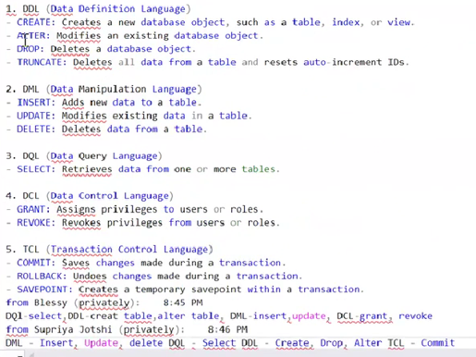
q. Explain Nvarchar & Nchar
For any language other than English, or if you need to support Unicode characters, you must use nchar or nvarchar in SQL Server.
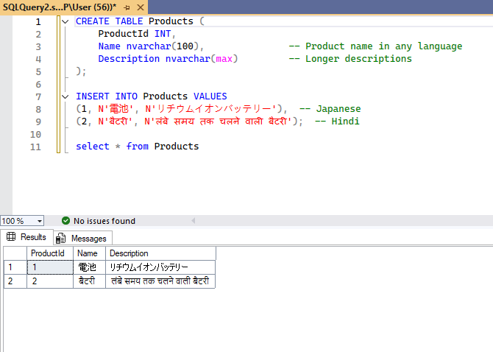

Below we have use simply varchar ,then it is not identifying data & returns question mark & we may lose data
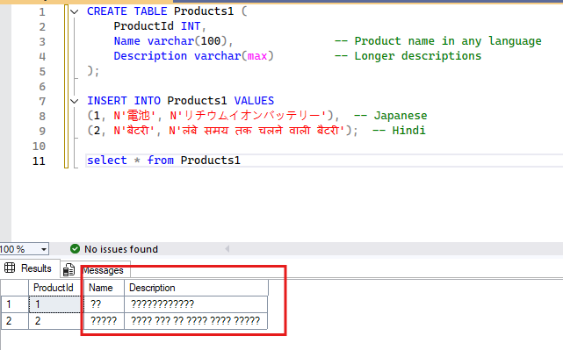
4.Primary key
Q. Difference between index seek & index can
Q. Clustered index & non clustered index
5.Difference between unique & primary key
6. 1)Write a query to create a table called product_123 with below columns , datatype and constraint
"productid" with int datatype and PK constraint
"Product_name" with varchar datatype and NOT NULL constraints
"Product_description" with varchar (max) datatype and default constraint as 'it’s a good product'
"cost" with int datatype and check constraint with cost > 1000
Answer:
create table product_123(
productid int primary key,
product_name varchar(255) not null,
product_description varchar(max) default 'it is a good product',
cost int check (cost > 1000));

Q. insert 4 values in above table
1st way:
insert into product_123 values
(1,'samsung','mobile phone', 25000),
(2,'one plus','ear phone', 4500),
(3,'lenovo','laptop', 65000),
(4,'hp','laptop', 55000);
2nd way:
INSERT INTO [dbo].[product_123]
([product id]
,[product name]
,[product description]
,[cost])
VALUES
(1,'Test','DEMO',10000),
(2,'Test2','DEMO2',20000),
(3,'Test3','DEMO3',30000),
(4,'Test4','DEMO4',40000)
INSERT INTO product_123 ([product id], [product name], cost)
VALUES (5, 'Product Five', 1500);
select * from [product_123]
6. Difference between DELETE and TRUNCATE.
The DELETE statement is part of the Data Manipulation Language in SQL. It is used to remove specific rows from a table based on a WHERE clause. If no WHERE clause is specified, all rows will be deleted, but the table structure and any associated indexes remain intact.

TRUNCATE is a SQL command that removes all rows from a table at once, but preserves the table structure, including:
Columns, Data types, Indexes, Constraints (like primary keys)
So, after you truncate a table, it's empty, but you can still insert new data into it because its design remains intact.

7. Why TRUNCATE is DDL and not DML?
Truncate resets the identity, auto increment
TRUNCATE is DDL, not DML, because it doesn't just remove data — it resets internal parts of the table (like auto-increment/identity), which affects the structure of how the table works.
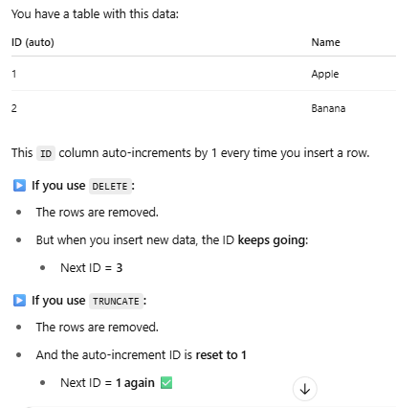
8.Difference between union ,union all & intersect
Union combines results from two or more SELECT statements and removes duplicates. All SELECT statements must have the same number of columns, with compatible data types
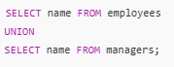
Union all combines results from two or more SELECT statements and includes duplicates.
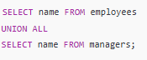
Intersect returns only the rows that exist in both result sets. Removes duplicates automatically
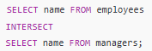
9.what is the default sorting order in order by
Ascending
10.difference between local & global table (# & ##)
A local temporary table is created using a single hash (#).It is only available to the session or connection that created it and is automatically deleted when that session ends.
CREATE TABLE #haro_products (
product_name VARCHAR(MAX),
list_price DEC(10,2)
A global temporary table is created using a double hash (##). It is accessible to all sessions and users and remains in the database until all sessions that reference it are closed.
CREATE TABLE ##heller_products (
product_name VARCHAR(MAX),
list_price DEC(10,2)
11.Use of between operator
The BETWEEN operator is used to filter the result set within a specified range.
It works with numbers, dates, and even text, and includes both lower and upper bounds.
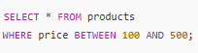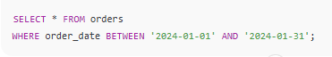
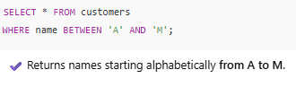
12.when will you use group by clause
The GROUP BY Statement in https://www.geeksforgeeks.org/sql-tutorialsql is used to arrange identical data into groups with the help of some functions.

13.Difference between inner join & full join
INNER JOIN gives you only the records that exist in both tables. FULL JOIN gives you everything, whether or not there's a match — and fills in the blanks with NULL.

14.Difference bw having & where clause
WHERE clause is used to place conditions on columns but what if we want to place conditions on groups? This is where the HAVING clause comes into use. We can use the HAVING clause to place conditions to decide which group will be part of the final result set. Also, we cannot use aggregate functions like SUM(), COUNT(), etc. with the WHERE clause. So, we have to use the HAVING clause if we want to use any of these functions in the conditions.

- ALTER TABLE dbo.tblstudent
ADD GENDER VARCHAR(20) Not NULL, mobile_no INT NULL ; this query will give error as while adding new column we can not give not null constraint
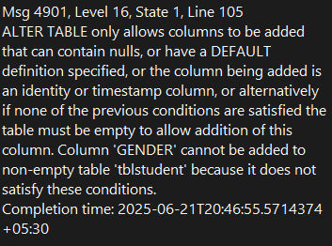
- To check type of variable
sp_help tblstudent (tablstudent is table name)
If there is both AND & OR operator with where clause ,then which will exeute 1st? Ans is AND operator.
SELECT
*
FROM
production.products
WHERE
(brand_id = 1 OR brand_id = 2)
AND list_price > 1000
ORDER BY
brand_id; In this query it will 1st fetch all list_price>1000 ,then it will check for brand_id=1 or 2
Day 2,class question
Use SQLTRAINING
select * from product_123;

--Write a query to update the product description column to 'its a bad product' where product id is 3 in product_123 table--
UPDATE product_123 SET product_description='its a bad product' WHERE productid = 3;

--Write a query to add column named product_type with datatype varchar(100) to product_123--
ALTER TABLE product_123
ADD product_type VARCHAR(100) NULL

--Write a query to update the data in product type column for all rows and update using another table it can be any table any data--
UPDATE product_123
SET product_type = (
SELECT product_name
FROM product_123 where productid= 4);

--Write a Query to find the products whose BRAND_ID is 9 and it's category _ID is 6 and model_year is 2016 from products table in production schema--
select * from production.products
where brand_id = 9 and category_id = 6 and model_year = '2016';

--Write a Query to find the products whose BRAND_ID is 9 or it's category _ID is 7--
select * from production.products
where brand_id = 9 or category_id = 6 ;

https://www.bing.com/videos/riverview/relatedvideo?q=variance+formula&mid=F65E7593AE0E0329E4F7F65E7593AE0E0329E4F7&FORM=VIRE

https://www.bing.com/videos/riverview/relatedvideo?q=variance+formula&mid=F65E7593AE0E0329E4F7F65E7593AE0E0329E4F7&FORM=VIRE

checksum_agg fun

-- Write a join query to fetch only matching records with columns category_name, Average of list_price from production.products & production.categories tables and I want to see avg of list_price per category with condition to show only the data where average of list_price is less 500 and sort it by asc order--
Or

Find all product categories where the average price of products is less than ₹500, and list them in order from cheapest to most expensive."
SELECT
c.category_name,
AVG(p.list_price) AS average_price
FROM
production.products p
JOIN
production.categories c ON p.category_id = c.category_id
GROUP BY
c.category_name
HAVING
AVG(p.list_price) < 500
ORDER BY
average_price ASC;

-- Write a query to find all data from products table and matching category name, average price of products from production.products & production. categories and display average price per category where average is greater than 500 and sort it by category name in desc order
SELECT c.category_name,
AVG(p.list_price) AS average_price
FROM
production.products p
LEFT JOIN
production.categories c ON p.category_id = c.category_id
GROUP BY
c.category_name
HAVING
AVG(p.list_price) > 500
ORDER BY
category_name DESC;

--Write a query which finds the brand names and the highest list price for each. In addition, it uses HAVING clause to find all brands whose max listprice is greater that 1000 and order by max list price descending.

SELECT
brand_name,
MAX(list_price) max_list_price
FROM
production.products p
INNER JOIN production.brands b
ON b.brand_id = p.brand_id
GROUP BY
brand_name
HAVING
MAX(list_price) > 1000
ORDER BY
MAX(list_price) DESC;

-- Write a query which finds the brand names and the highest list price for each. In addition it uses HAVING clause to find all brands whose max listprice is less than 1000 and order by max list price default
SELECT
brand_name,
MAX(list_price) max_list_price
FROM
production.products p
INNER JOIN production.brands b
ON b.brand_id = p.brand_id
GROUP BY
brand_name
HAVING
MAX(list_price) < 1000
ORDER BY MAX(list_price) ;

--Write a query which uses the MIN() function in the HAVING clause to get the product category with the minimum list price greater than 500.

SELECT
c.category_name,
MIN(p.list_price)
FROM
production.products p
JOIN
production.categories c ON p.category_id = c.category_id
GROUP BY
c.category_name
HAVING
MIN(p.list_price) > 500

VAR() AND VARP() STDEV() AND STDEVP() Function
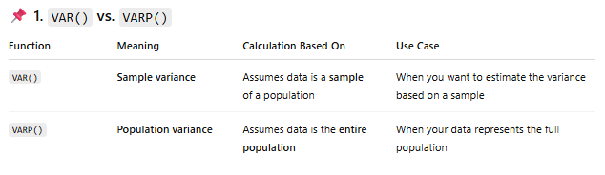
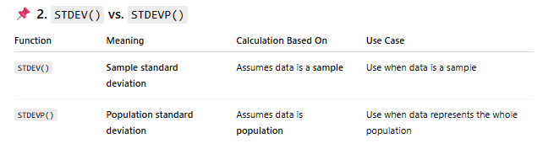
Variance measures the spread or dispersion of data points in a dataset. • Variance gives you a numerical value that describes how far each data point is from the mean (average) of the dataset.
• A high variance means that the data points are spread out over a wider range of values.
• A low variance indicates that the data points are closer to the mean, showing less variability.
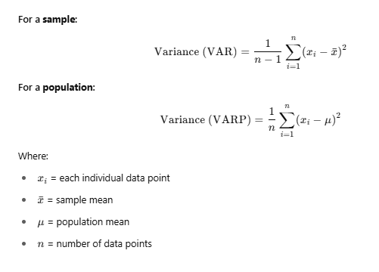
The standard deviation is the square root of variance. A larger standard deviation means data points are more spread out, while a smaller standard deviation indicates they are closer to the mean.
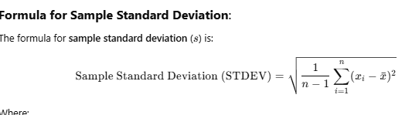
- Window Function in sql

A window function performs a calculation across a set of related rows, while still showing each individual row in the result.
You have a list of students with their marks. You want to: know the average marks in their class, their rank, or the total marks of all students in their class ➕
Normally, if you used a GROUP BY, you'd just get one row per class — and you’d lose individual student details.
But with a window function, you can see each student’s data PLUS the average/total/rank for their class right next to it — all in one result.
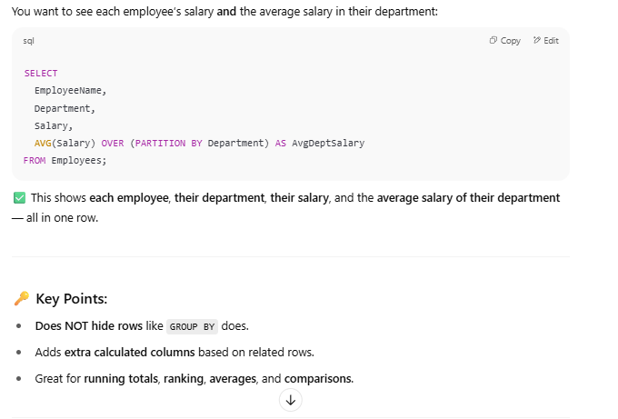
• Do not group the result set: While traditional aggregate functions (like SUM(), AVG(), COUNT()) collapse rows into a single summary result, window functions retain the individual rows and simply provide additional calculations across those rows.
• Operate over a "window": The "window" is the set of rows over which the function operates. This set of rows can be defined by partitions and ordering criteria (using the PARTITION BY and ORDER BY clauses).
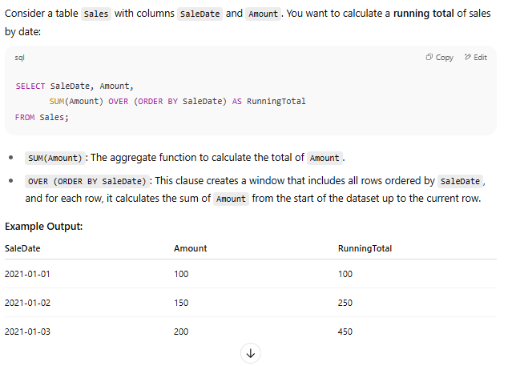

CHECKSUM_AGG() is an aggregate function in SQL Server that returns the checksum value of a set of values over multiple rows.
This is a simplified way to determine if the data in a row or group of rows has changed:
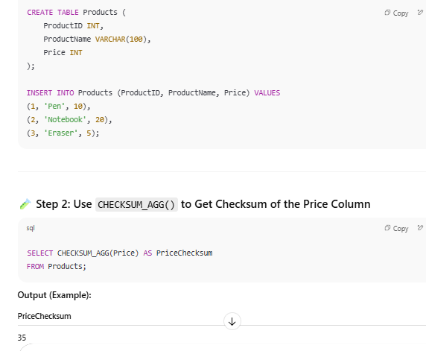
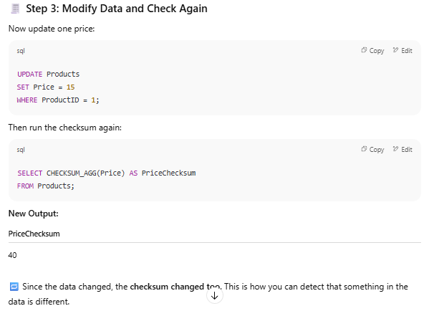
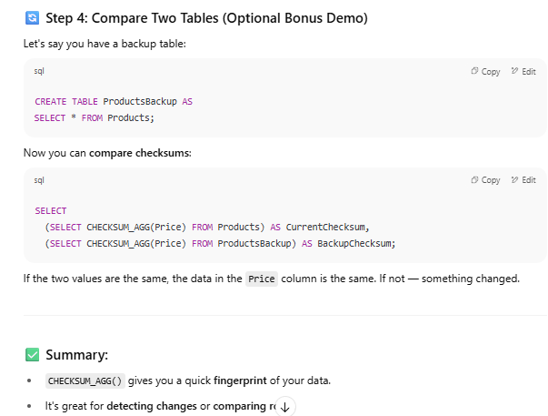
- CHECKSUM_AGG does NOT return the sum of values.
- It returns a hashed integer based on the values' patterns.
- Even if you change just one number, the checksum will probably change.
- CHECKSUM()works with non-numeric values by converting them to an internal binary format, then applying a hashing algorithm to return a hashed integer.
- If column_name is not numeric, wrap it with CHECKSUM() like this:
  - SELECT CHECKSUM_AGG(CHECKSUM(column_name)) FROM table_name;
- Difference between ceiling floor & round function:
- Ceiling: It rounds up to the next whole number.
- Floor: It rounds down to the previous whole number.
- Round: Rounds a number to a specified number of decimal places using normal rounding rules. If >=0.5 ,next whole no. If <0.5 previous no.
select Round(6.65,0) as round_no
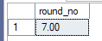

- SELECT ROUND(4.36, 1);
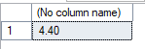

#2 types of fun
Scalar valued & table valued
--create a function which fetches all the column from employee table where the income is more than the user input

--1ST WAY
CREATE FUNCTION income (@salary INT)
RETURNS TABLE
AS
RETURN (
SELECT
name,
occupation,
working_date,
working_hours,
salary AS income
FROM
employee
WHERE
salary > @salary
);

SELECT * FROM [dbo].[income] (2000)
--2ND WAY
Create function incomefuntion (@value int)
RETURNS TABLE
as
return (
select * from employees
where salary > @value
)
select * from incomefuntion (7000)

Q. difference between table scan & table seek
- CAST FUNCTION IN SQL
The CAST() function in SQL is used to convert one data type to another.

✅ Basic Syntax:
CAST(expression AS target_data_type)
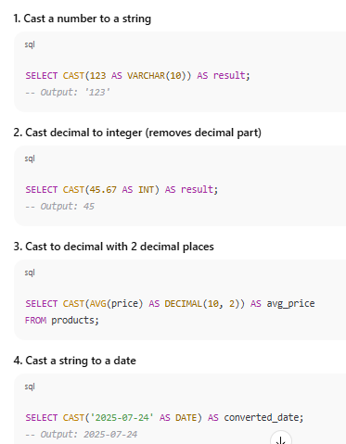
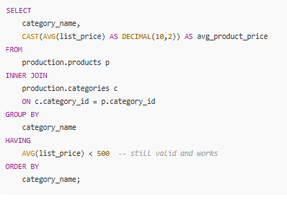

- CASE IN SQL
The CASE function in SQL is used to apply conditional logic — like an IF...THEN...ELSE statement — within a query.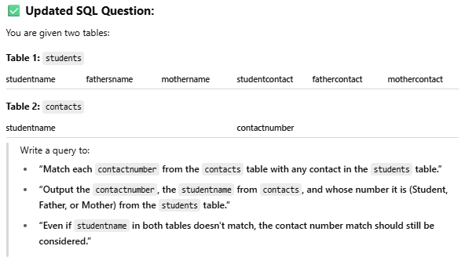
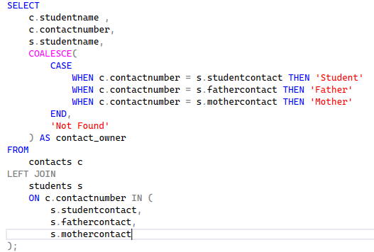

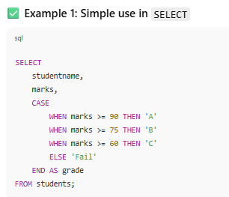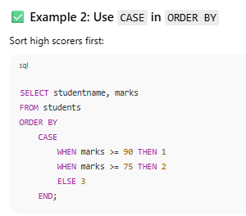
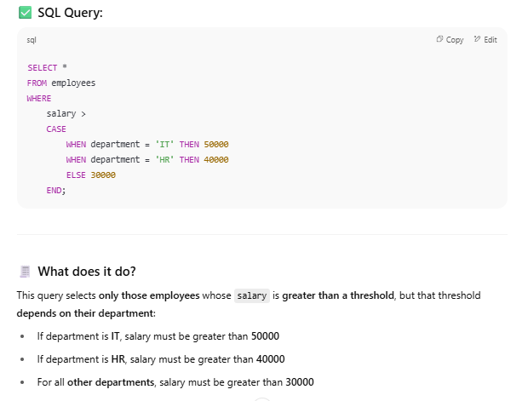

- ROLL UP FUNCTION
ROLLUP is used with the GROUP BY clause to create subtotals and a grand total in the query results.
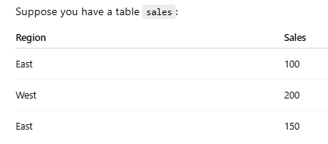
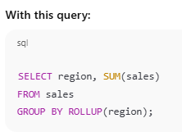
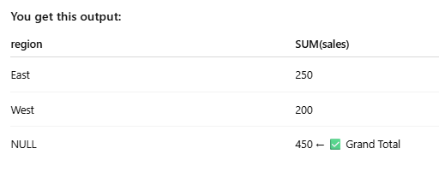
We can replace the null(which is total value) by using coalesce fun
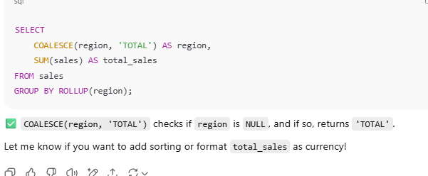

What Is a Transaction in SQL?
A transaction in SQL is a group of one or more SQL commands that are treated as a single unit of work.
That means:
Either all the commands succeed and are permanently saved,
or none of them happen (rolled back) if something goes wrong.
**********************************.****************************
CTE (Common Table Expression) in SQL 📘
A CTE (Common Table Expression) is a temporary result set in SQL that is created using the WITH keyword. It helps make complex queries easier to read, write, and manage.
A CTE exists only during the execution of a query and is not stored permanently in the database.


